MEMORANDUM
To: | Charlie Refvem, Department of Mechanical Engineering, Cal Poly SLO
 | crefvem@calpoly.edu
From: | Antonio Ventimiglia
 | ventimig@calpoly.edu
Date: | October 19th, 2025
RE: | Homework 0x03: System Modeling

Developing a dynamic model of the Romi robot, which is still under development, provides critical insight into its expected behaviors and informs effective control strategies. Figure 1 presents an illustration of the Romi platform.
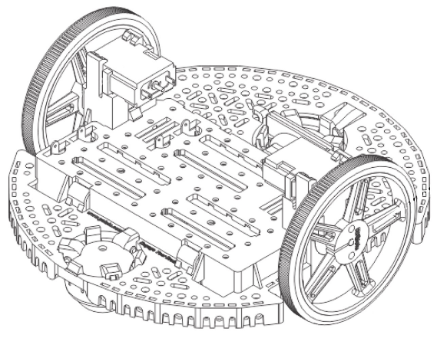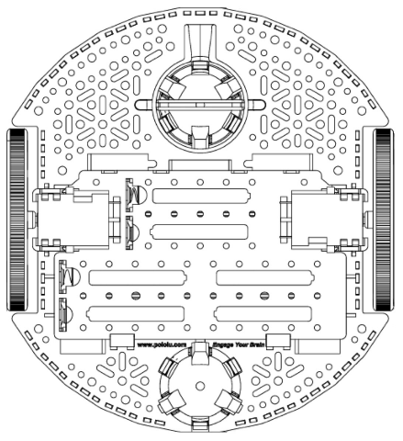
Figure 1. Illustration of Romi Robot
Kinematics
It was chosen that the local x-axis for the Romi will go along its long axis, pointing towards the “front” of the bot. Figure 2 shows the respective velocity vectors associated with the components of the Romi bot with this given local coordinate system. Note the two crucial dimensions provided for the Romi: The radius of the wheel from its axis of rotation to the contact surface, $r$, and the track width of the wheels, $w$.
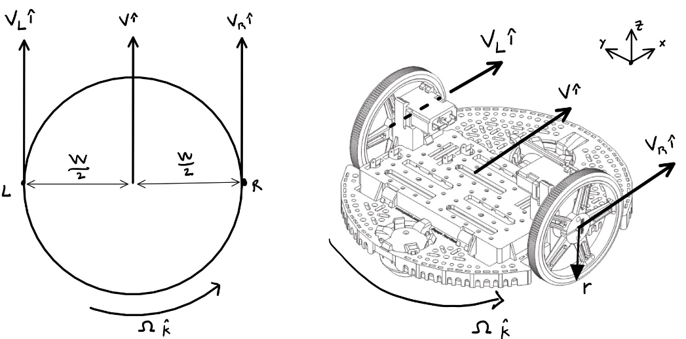
Figure 2. Illustration of Romi kinematics in its local coordinate system
Applying the equations for general plane motion to Figure 2, we can derive the velocity of the right wheel with respect to the left wheel in their local coordinate systems (Equation 1a):
$$\begin{aligned}V_{R} \hat{i}=V_{L} \hat{i}+\left(Ω \hat{k}\right)×\left(-w \hat{j}\right)\#\left(1a\right)\end{aligned}$$
where $V_{R}$ and $V_{L}$ are the translational velocities of the right and left wheels’ centers (respectively), $Ω$ is the Romi’s yaw rate, and $w$ is the track width. Equation 1a can be arranged into Equation 1b as follows.
$$\left(V_{R}-V_{L}\right) \hat{i}=wΩ \hat{i}$$
$$\begin{aligned}Ω=\frac{V_{R}-V_{L}}{w} \#\left(1b\right)\end{aligned}$$
The translational velocity of each wheel can be expressed as a function of each wheel’s angular velocity, assuming there is a no-slip condition at the contact point between the wheel and the ground. This assumption will be discussed later. This relation is as follows:
$$\begin{aligned}V_{center}=Ω_{wheel}*r \#\left(2\right)\end{aligned}$$
where $V_{center}$ is the translational velocity of the center of the wheel, $Ω_{wheel}$ is the angular velocity of the wheel, and $r$ is the radius of the wheel. Substituting Equation 2 into Equation 1b for both wheels, we find Equation 3
$$\begin{aligned}Ω=\frac{r}{w}{(Ω}_{R}-Ω_{L}) \#\left(3\right)\end{aligned}$$
which finds the yaw rate of the Romi as a function of each wheel’s rotational speed. It is important to note that the radii for both wheels are the same.
Similarly, the velocity of the center of the Romi, $v$, is found using the general plane motion equation with respect to the left wheel (Equation 4a)
$$\begin{aligned}v \hat{i}=V_{L} \hat{i}+\left(Ω \hat{k}\right)×\left(-\frac{w}{2} \hat{j}\right)\#\left(4a\right)\end{aligned}$$
$$\begin{aligned}v \hat{i}=\left(V_{L}+\frac{w}{2}Ω\right) \hat{i} \#\left(4b\right)\end{aligned}$$
If we plug in Equation 3 into Equation 4b, we get Equation 5, which gives the velocity of the Romi as a function of each wheel’s angular velocity
$$\begin{aligned}v=\frac{r}{2}{(Ω}_{R}-Ω_{L}).\#\left(5\right)\end{aligned}$$
Coordinate Systems
The Romi’s local positioning can be expressed in global coordinates using $ψ_{R}$, which is the heading angle of the Romi from the global “x” axis. This is illustrated in Figure 3.
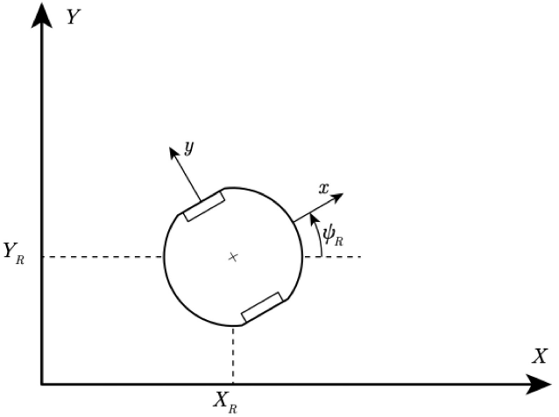
Figure 3. Romi's global and local coordinate systems.
From visual analysis of Figure 3, the local coordinates can be decomposed into their global coordinate components:
$$\hat{i}=cosψ \hat{I}+sinψ J$$
$$\#\left(6\right) -sinψ \hat{I}+cosψ \hat{J}$$
This means any vector given into the local coordinates can be transformed into the local coordinate system for the Romi.
Since the Romi is assumed only to drive forward or backward, the global velocities, $\dot{X}$ and $\dot{Y}$, can be described with Equations 6 and 7
$$\begin{aligned}\dot{X}=vcosψ\#\left(6\right)\end{aligned}$$
$$\begin{aligned}\dot{Y}=vsinψ\#\left(7\right)\end{aligned}$$

$\underline{x}=\left[\begin{matrix}X_{R} \\ Y_{R} \\ ψ_{R} \\ s \\ Ω_{L} \\ Ω_{R}\end{matrix}\right]$, $u=\left[\begin{matrix}u_{L} \\ u_{R}\end{matrix}\right],$ $\underline{y}=\left[\begin{matrix}X_{R} \\ Y_{R} \\ ψ_{R} \\ s \\ v \\ Ω\end{matrix}\right]$
Words
$$\underline{\dot{x}}=\left[\begin{matrix}{\dot{X}}_{R} \\ {\dot{Y}}_{R} \\ {\dot{ψ}}_{R} \\ \dot{s} \\ {\dot{Ω}}_{L} \\ {\dot{Ω}}_{R}\end{matrix}\right]=\left[\begin{matrix}\frac{r}{2}cosψ_{R}(Ω_{R}-Ω_{L}) \\ \frac{r}{2}sinψ_{R}(Ω_{R}-Ω_{L}) \\ \frac{r}{w}(Ω_{R}-Ω_{L}) \\ \frac{r}{2}(Ω_{R}-Ω_{L}) \\ \frac{1}{τ}(Ku_{L}-Ω_{L}) \\ \frac{1}{τ}(Ku_{R}-Ω_{R})\end{matrix}\right]$$
Words
$$y= \left[\begin{matrix}X_{R} \\ Y_{R} \\ ψ_{R} \\ s \\ \frac{r}{2}(Ω_{R}-Ω_{L}) \\ \frac{r}{w}(Ω_{R}-Ω_{L})\end{matrix}\right]$$
Words

Assignment
The following steps will help guide you through development of your kinematic model.
- Start by drawing a detailed, but simplified, schematic of your system with all important geometry clearly defined; for example, things like:
  - wheel radius
  - track width
  - Romi diameter
- Consider the kinematics associated with the robot and determine equations or expressions for the following parameters:
  - The angular velocity of the robot with respect to its environment.
    - OMEGA, and phi-dot
  - The velocity of the robot origin in a coordinate system attached to the robot.
    - x-dot, y-dot
  - The velocity of the robot origin in a coordinate system attached to the environment.
    - X-dot, Y-dot
- Consider the dynamics associated with each motor if it is treated as a simple first-order system. That is, you may assume that each motor obeys the following differential equation: where is the motor speed and is the applied voltage to the motor terminals. What do and represent?
  - Tau bullshit
- Formulate a set of differential equations that incorporate all the kinematic relationships you've determined in combination with the simplified motor dynamics . That is, choose a set of state variables associated with the robot at an arbitrary location and orientation, and develop a first-order ODE for each state variable.
Compose a set of state equations from these first-order ODEs to represent the system dynamics in the form where the components of are your state variables and the components of are your system inputs.
  - X~

- Formulate a set of output equations that relate the state variables to desired output parameters that you want to plot or study. That is, come up with a set of desired outputs from your simulation, some of which may be state variables themselves, and work out the relationship between each output and your state variables and inputs in the form .
  - Y~

Deliverables
For this assignment, you will each submit a single memo presenting your dynamic model.
- Make sure that the memo includes a moderately thorough dynamic analysis of your system design with very thorough annotations. This should include all the analysis leading up and including your state-space model.
- Present the final state-space model, formatted clearly -- that is, properly typeset -- in the body of your memo in addition to the supporting analysis which can be done neatly by hand digitally or done on paper and scanned.
Equations can be typeset using markup or with other tools. You may need to do a bit of reading to figure out the basics of equation formatting.

Finally, include a section in your memo where you fully address each of the discussion questions below:
- Explore the validity of the no-slip assumption and any other assumptions required for the kinematic model in favor of a full dynamic model. Consider things like how the nonlinear aspect of the motors may or may not easily integrate with the model, how the mass and friction properties of the system may influence the model, and any other effects that may not match the idealized nature of the kinematic model. Is the kinematic model good enough for our purposes?
- In Lab you will run (or have already ran) step response tests to experimentally determine the parameters associated with Romi's motors. Is it valid to assume that the parameter values while driving forward are the same as while turning? Compare pivoting in place and driving in a straight line, will both of these cases have the same effective inertia loading the motors?
- One of the problems with models like this is that significant deviation or drift will occur between the simulation and the behavior of the real vehicle, especially when accumulated over a long simulation. The concept of dead reckoning suggests that we can predict the position of a system simply by integrating its velocity or acceleration over time. Naturally, small deviations, like those caused by minor wheel slip, add up over time. A small error in velocity, once integrated over time to produce position, can lead to wildly inaccurate estimations of position.
How can we correct for this drift error? What other information would help us keep our simulated model tracking with reality? Hint: consider what kind of sensors may be added to the robot to measure the value of your selected state variables.
- While this is not a controls course, you will need to implement some kind of controller on your robot to complete the term project. For this question, investigate ways in which you may incorporate feedback into your system to make the robot move in ways that will be advantageous for the term project.
Address nuances such as:
  - What sensor inputs will be useful for feedback.
  - How you might split up a complicated path into segments such as straight lines, circular arcs, in-place turns, etc.
- Is it possible to determine the orientation and location of the robot after it has followed a specific path simply by knowing the angle swept out by each wheel? If not, would it be possible to know the orientation and location with a time-history of the angle swept out by each wheel? If you know the robot's orientation and location, can you figure out the angle swept out by each wheel?
Investigate what information is required to track the robots absolute position in space, or possibly its position relative to a particular maneuver, like a circular arc. What kind of data will you need to track in your firmware to make use of this information?

